**.BulkSale()**  
Reference resolution: 1280x720  
  
Key:  
[Native X, Native Y](Red, Green, Blue)🡨clickPoint  
**%X.XXXXXXX, %Y.YYYYYYYY**

Look for Item Bag, Click:  
item.png  
[981, 18](234, 229, 225)🡨   
**76.640625, 2.5**

Look for Bulk Sale, click:  
  
[910, 677](255, 255, 255)🡨   
**71.09375,** **94.02777777777778**  
[927, 661](52, 66, 82)  
**72.421875,** **91.80555555555556**



Look for green Sell button, click:  
  
[1172, 675](251,248, 237)🡨  
**91.5625, 93.75**  
[1153, 674](80, 130, 84)  
**90.078125, 93.61111111111111**



Look for blue Sell button, click:  
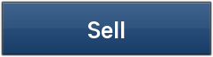  
[744, 491](255,255,255)🡨  
**58.125, 68.19444444444444**  
[731, 491](49, 85, 127)  
**57.109375, 68.19444444444444**

Look for blue OK button, click:  
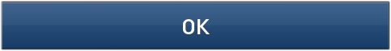[626,482](255, 255, 255)🡨  
**48.90625, 66.94444444444444**[614, 477](49, 85, 127)  
**47.96875, 66.25**

Look for the Close button, click:  
  
[1238,20](28, 31, 40)🡨  
**96.71875, 2.777777777777778**  
[1237, 29](216, 216, 218)  
**96.640625, 4.027777777777778**



Verify bag Closed:  
item.png  
[981, 18](234, 229, 225)🡨   
**76.640625, 2.5**

*Native X , Y and RGB values were determined using the attached PSD.  
*%X and %Y are determined by take the native value and dividing it by the respective resolution, the results are multiplied by 100.

